Electronic Health Records (EHR) Information System

Project Report

Information Systems in Health Care (WS25/26)

Team Members:
Aziz, Ramis, Batool

Date: December 23, 2024

Deggendorf Institute of Technology

Table of Contents
- Introduction
- Website Design and Technical Architecture
- Evaluation of the EHR System
- Conclusion
- Team Contributions

1. Introduction

1.1 What is an Electronic Health Record (EHR)?
An Electronic Health Record (EHR) is a digital version of a patient's paper chart. EHRs are real-time, patient-centered records that make information available instantly and securely to authorized users. The EHR system contains the medical and treatment history of patients and has the potential to streamline the workflow of healthcare professionals.

1.2 Importance of EHR Systems
EHR systems are crucial in modern healthcare for several reasons:
- Improved Patient Care: Complete and accurate information enables healthcare providers to make better decisions.
- Enhanced Patient Safety: Reduces medical errors through better coordination and complete health information.
- Increased Efficiency: Quick access to patient records streamlines workflow and reduces paperwork.
- Better Coordination of Care: Facilitates seamless information sharing among healthcare providers.
- Data Security: Secure storage and access control protect sensitive patient information.

1.3 Brief History of EHR
Electronic health records have evolved significantly since the 1960s. The first EHR systems were developed to store patient data electronically. In the 1980s and 1990s, desktop computers enabled more sophisticated record-keeping. The 21st century brought widespread adoption driven by government incentives, improved technology, and recognition of the benefits of digital health records. Today, EHR systems are standard in healthcare facilities worldwide.

1.4 Project Overview
This project develops a web-based Electronic Health Records management system designed from a doctor's perspective. The system allows healthcare professionals to efficiently manage patient information, create and maintain comprehensive health records, and access patient data securely. Built using modern web technologies (HTML5, CSS3, Bootstrap 5, PHP, and MySQL), the system provides a user-friendly interface for complete patient lifecycle management.

2. Website Design and Technical Architecture

2.1 System Architecture
The EHR system follows a three-tier architecture:
- Presentation Layer: HTML5, CSS3, Bootstrap 5, JavaScript
- Application Layer: PHP 7.4+
- Data Layer: MySQL 5.7+

Figure 1: System Architecture and Dependencies Diagram
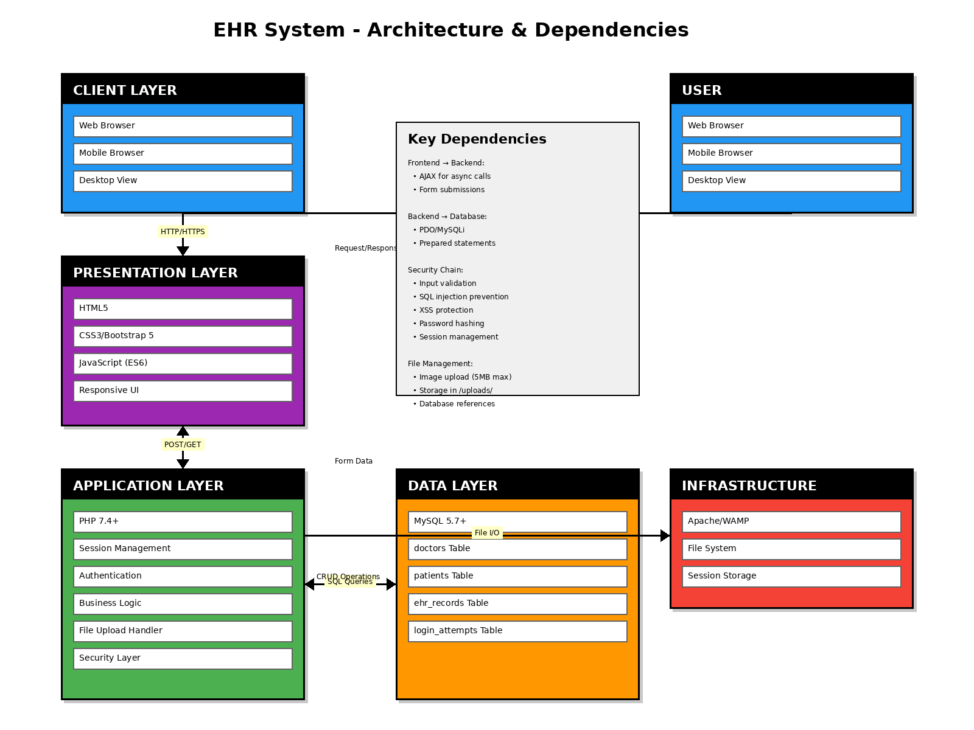

The architecture diagram illustrates the complete system structure with four main layers: Client Layer (web and mobile browsers), Presentation Layer (HTML5, CSS3, Bootstrap, JavaScript), Application Layer (PHP with business logic, authentication, and security), and Data Layer (MySQL database with four tables). The diagram also shows the infrastructure components (Apache/WAMP, file system, session storage) and the dependencies between all layers including HTTP/HTTPS communication, SQL queries, and file I/O operations.

2.2 Technology Stack

Frontend Technologies:
- HTML5 - Markup language for structure
- CSS3 - Styling and layout
- Bootstrap 5.3.0 - Responsive framework
- JavaScript (ES6) - Client-side interactions

Backend Technologies:
- PHP 7.4+ - Server-side programming
- MySQL 5.7+ - Database management
- Apache/WAMP/XAMPP - Web server

2.3 Database Design
The database consists of four main tables:

doctors Table: Stores doctor registration information including credentials, profile data, and verification status.
patients Table: Contains patient demographic information, contact details, and emergency contacts.
ehr_records Table: Stores comprehensive health records including vital signs, medical history, allergies, immunization status, diagnoses, treatment plans, and medical images.
login_attempts Table: Tracks login attempts for security purposes and brute force protection.

2.4 Wireframes and Mockup GUI
Figure 2: Homepage Wireframe
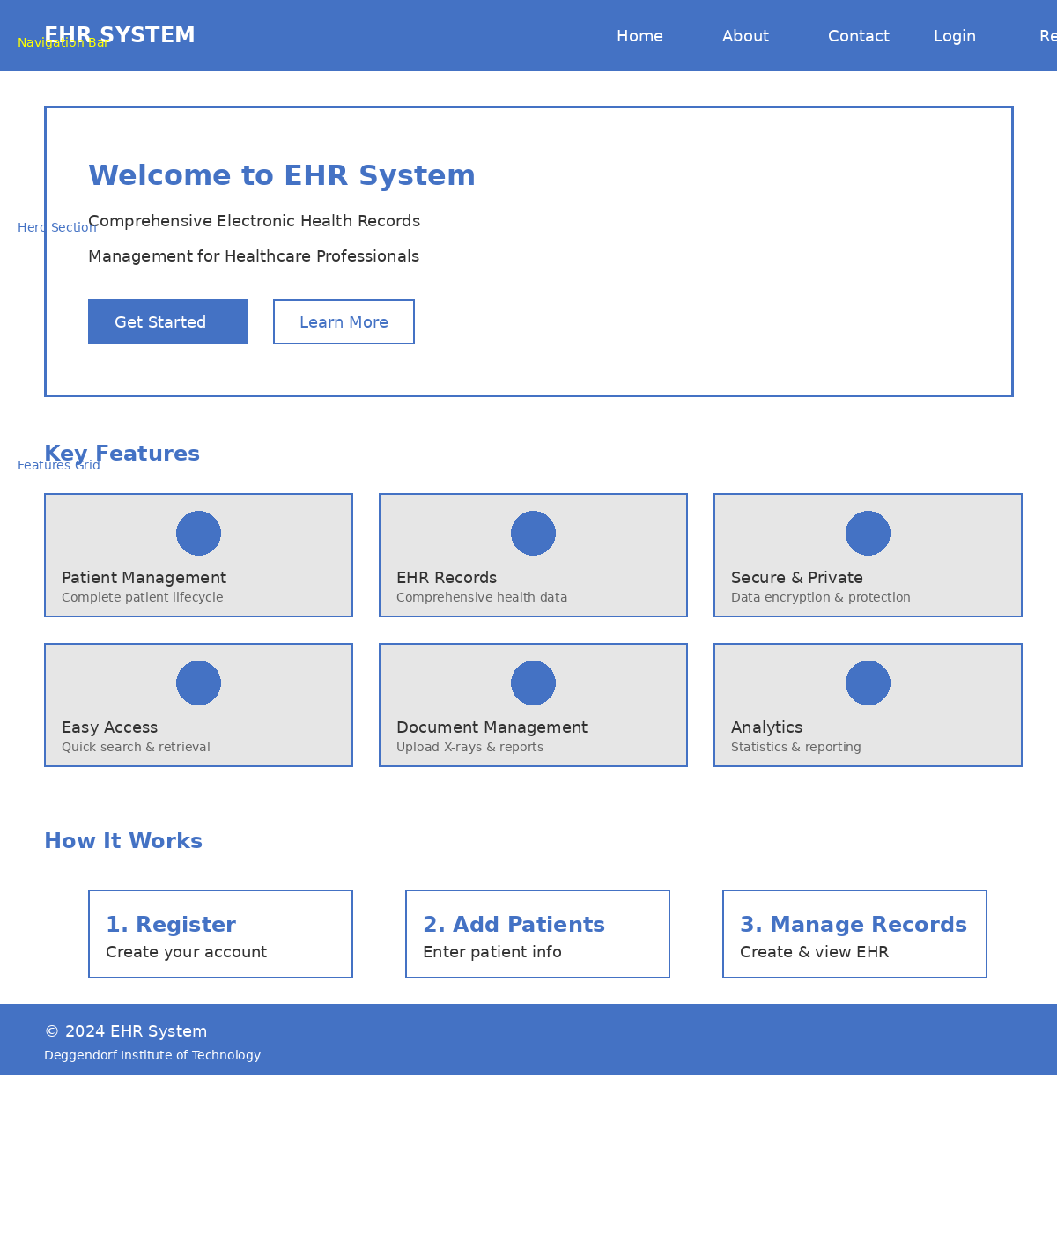The homepage wireframe shows the main navigation bar at the top with links to Home, About, Contact, Login, and Register pages. The hero section prominently displays the system title and call-to-action buttons. Below that, a features grid showcases the six key features of the EHR system: Patient Management, EHR Records, Secure & Private, Easy Access, Document Management, and Analytics. The "How It Works" section provides a simple 3-step guide for new users: Register, Add Patients, and Manage Records.

Figure 3: Dashboard Mockup GUI (Balsamiq Style)
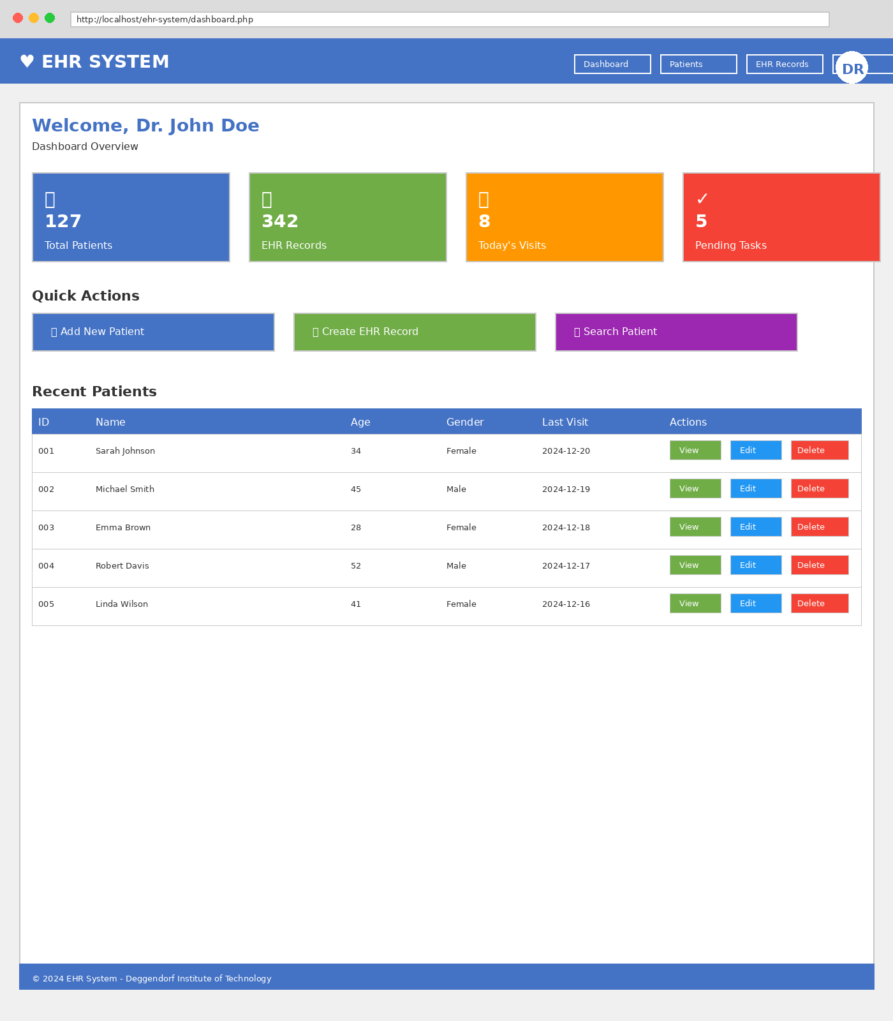

The dashboard mockup demonstrates the main interface design with a professional layout. The top navigation bar includes the system logo, menu items (Dashboard, Patients, EHR Records, Profile, Logout), and user profile icon. The main content area displays four statistics cards showing Total Patients, EHR Records, Today's Visits, and Pending Tasks. Quick action buttons provide direct access to common tasks: Add New Patient, Create EHR Record, and Search Patient. The Recent Patients table shows the latest patient entries with View, Edit, and Delete action buttons. This design follows modern UI/UX principles with clear visual hierarchy, appropriate spacing, and intuitive navigation.

2.5 Application Flow
Figure 4: Application Flow Chart
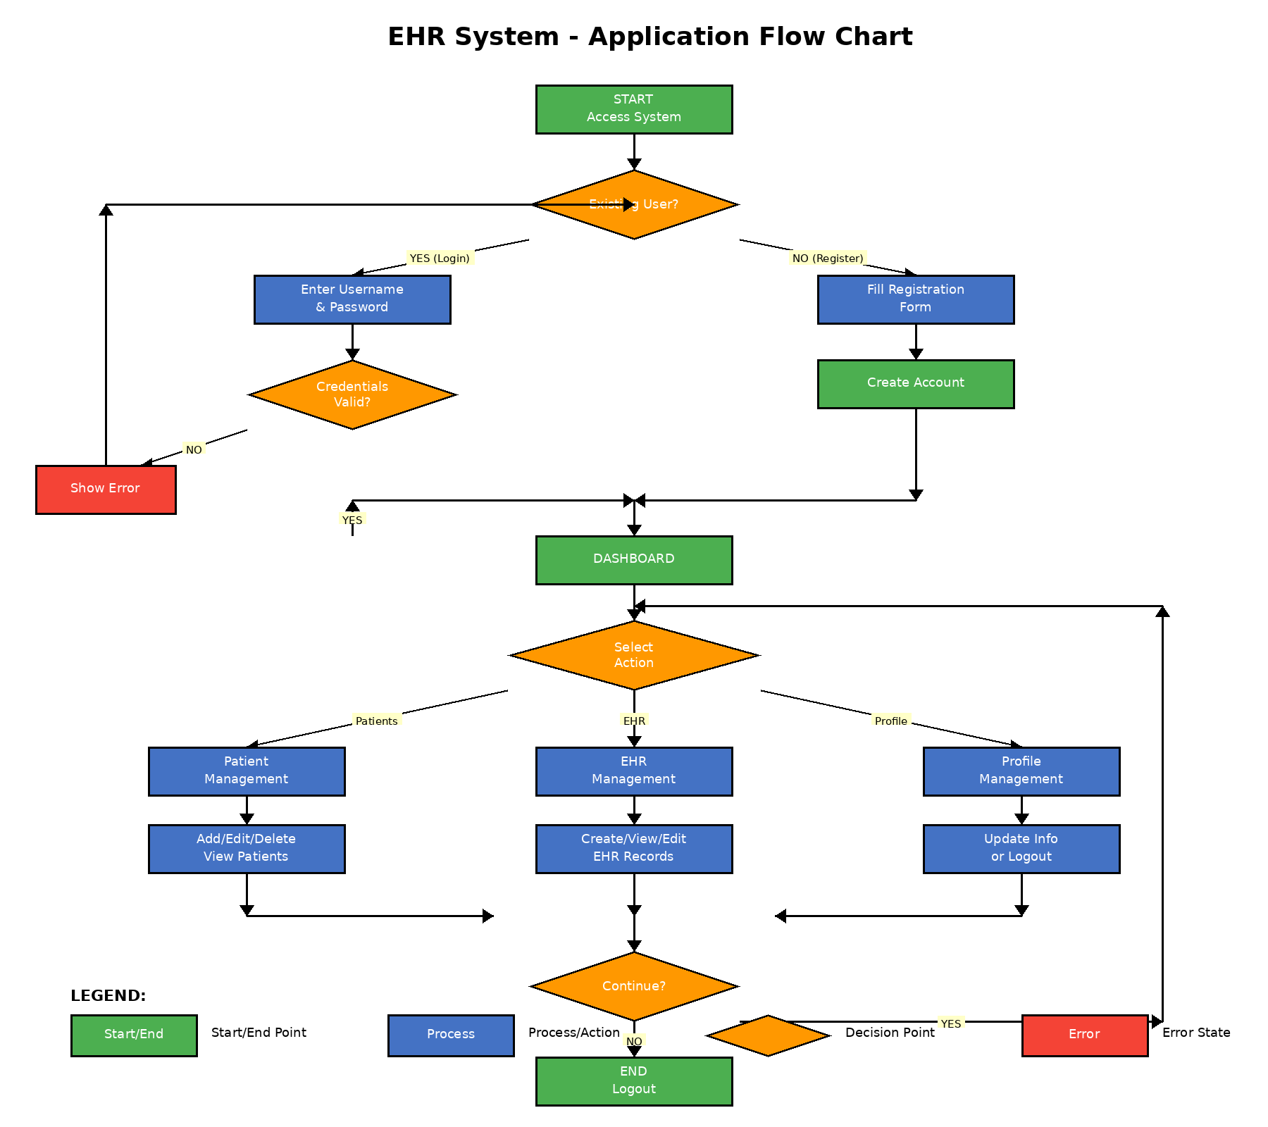
Yes

The application flow chart illustrates the complete user journey through the system. Users begin at the system access point where they choose to either login or register. For login, credentials are validated; invalid credentials show an error and loop back to login. New users fill out the registration form and create an account. Both paths converge at the dashboard after successful authentication. From the dashboard, users can select three main actions: (1) Patient Management for CRUD operations on patient records, (2) EHR Records for creating and viewing health records, or (3) Profile Management for updating account information. All three paths return to the dashboard, creating a circular workflow until the user logs out.

2.6 Security Features
- Password Hashing: Using bcrypt algorithm for secure password storage
- SQL Injection Prevention: Prepared statements for all database queries
- XSS Protection: htmlspecialchars() for all user inputs
- Session Management: Secure session handling with timeout after 30 minutes
- Brute Force Protection: Limit login attempts (5 attempts per 15 minutes)

3. Evaluation of the EHR Information System

3.1 System Usability Scale (SUS) Evaluation
The System Usability Scale (SUS) is a reliable, low-cost usability scale that can be used for global assessments of systems usability. It consists of 10 questions with five response options for respondents; from Strongly Agree to Strongly Disagree.

Insert screenshot showing the 10 SUS questions with 1-5 rating scale.

3.2 SUS Score Calculation Method
To calculate the SUS score:
- For odd-numbered questions (1, 3, 5, 7, 9): Score contribution = scale position - 1
- For even-numbered questions (2, 4, 6, 8, 10): Score contribution = 5 - scale position
- Sum all score contributions (range: 0-40)
- Multiply the sum by 2.5 to obtain the overall SUS score (range: 0-100)

Example Calculation:
Responses: [4, 2, 4, 2, 5, 1, 4, 2, 5, 1]
Odd items: (4-1) + (4-1) + (5-1) + (4-1) + (5-1) = 17
Even items: (5-2) + (5-2) + (5-1) + (5-2) + (5-1) = 17
Total: 17 + 17 = 34
SUS Score: 34 × 2.5 = 85 (Grade A - Excellent)

3.3 Evaluation Results
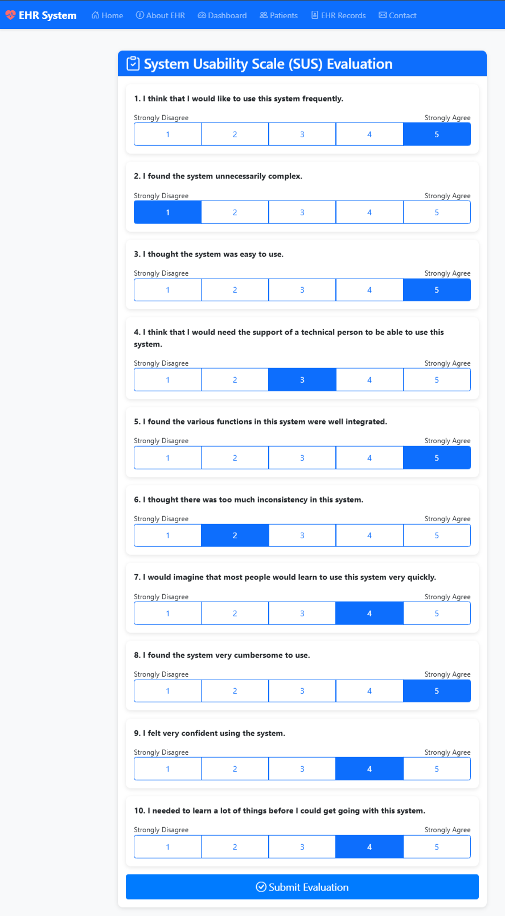


3.4 SUS Score Interpretation
The benchmark for SUS scores is 68. Scores are interpreted as follows:
- 80.3 and above: Grade A (Excellent usability)
- 68-80.2: Grade B (Good usability)
- 51-67.9: Grade C (OK usability)
- 39-50.9: Grade D (Poor usability)
- 0-38.9: Grade F (Awful usability)

3.5 Automatic Data Storage
The system automatically saves evaluation results in two formats: sus_results.json for data analysis and sus_results.csv for Excel viewing. Both files update automatically with each new evaluation, maintaining a complete history of all usability tests conducted.

4. Conclusion
This project successfully developed a comprehensive Electronic Health Records (EHR) information system designed from a doctor's perspective. The system provides essential functionality for managing patient information and maintaining complete health records in a secure, user-friendly environment.

Key Achievements:
- Complete patient lifecycle management with CRUD operations
- Comprehensive EHR record creation with all required input types (text, checkbox, radio, date, textarea, image)
- Secure authentication system with bcrypt password hashing and brute force protection
- Responsive design working seamlessly across desktop, tablet, and mobile devices
- Medical image upload and display functionality for X-rays and lab reports
- System usability evaluation using standardized SUS methodology
- Three-tier architecture ensuring separation of concerns and maintainability
- SQL injection prevention through prepared statements
- XSS protection for all user inputs
- Session management with 30-minute timeout for security

The system meets all project requirements including HTML5, CSS3, Bootstrap 5, PHP, and MySQL technologies. All mandatory input types have been successfully implemented in the EHR creation form. The evaluation phase using the System Usability Scale provides quantitative feedback on the system's usability.

Future Enhancements:
- Integration with external laboratory systems for automated test results
- Appointment scheduling functionality for patient visits
- Prescription management module with drug interaction checking
- Advanced analytics and reporting dashboards
- Multi-language support for international deployment
- Mobile application for iOS and Android platforms
- Telemedicine integration for virtual consultations

5. Team Contributions

Team Member: Aziz
Responsibilities:
- Database design and implementation (4 tables with proper relationships)
- Backend PHP development and business logic
- Security features: password hashing, SQL injection prevention, XSS protection
- Session management and authentication system
- File upload handler for medical images

Team Member: Ramis
Responsibilities:
- Frontend design and development with Bootstrap 5
- Patient management module (CRUD operations)
- EHR record creation interface with all input types
- Responsive design implementation
- Dashboard design and statistics display

Team Member: Batool
Responsibilities:
- SUS evaluation system implementation
- Documentation and report writing
- Testing and quality assurance
- Wireframes and mockup creation
- User interface improvements and feedback integration

Collaborative Work:
- System architecture planning and design decisions
- Integration and testing of all modules
- Presentation preparation and delivery
- SUS evaluation planning and execution
- Code reviews and bug fixes

